**Istanbul Technical University**

**Faculty of Computer and Informatics**



**BLG438E Digital Signal Processing Lab**

**Experiment 6**

**Cem Yusuf Aydoğdu**

**150120251**

# Modulation Techniques

Modulation can be defined as adding information to a carrier signal in order to transfer the information from one place to another place. There are three common techniques used in order to produce modulation: Amplitude Modulation (AM), Frequency Modulation (FM), Phase Modulation (PM). Also, there are more complex methods which are different combinations of these common techniques.

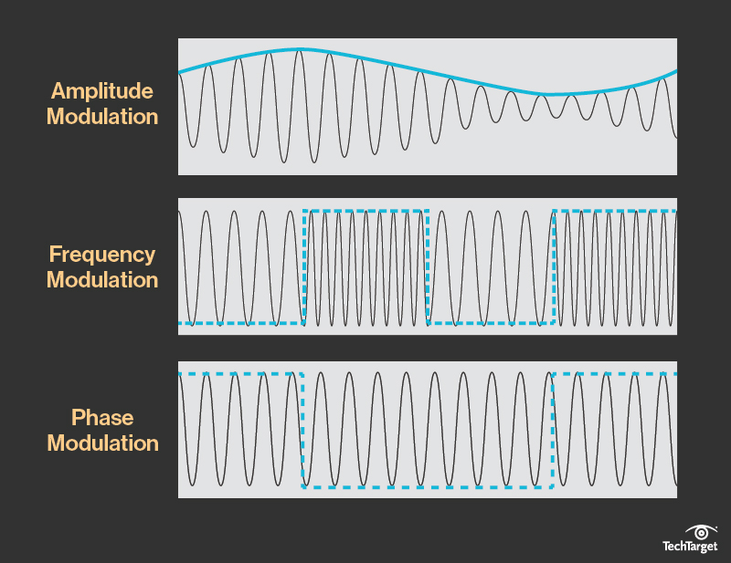

Figure 1: Different basic modulation techniques

(source: <http://searchnetworking.techtarget.com/definition/modulation>)

**Amplitude Modulation**

Amplitude of the carrier signal is varied in order to represent the data in this type of modulation.

Advantages**:** Easier to implement

Disadvantages: More susceptible to noise

Less efficient

**Frequency Modulation**

In frequency modulation, frequency of the carrier waveform is varied to reflect the data.

Advantages: More resilient to noise

More efficient

Disadvantages: Requires complicated hardware

Limitation of frequency spectrum

**Phase Modulation**

Phase of the carrier signal is varied in order to represent the data in this type of modulation.

Advantages: Provides higher data rate

Less susceptible to noise

Requires less frequency usage

Disadvantages: More complex since it requires two signals with phase difference

# Experiment

In this experiment, amplitude modulation technique was implemented with TMS C5515 digital signal processing kit. C Code for the kit which runs in an interrupt is given below.

Main principle is to multiply the carrier signal with the input signal. When the input signal is at its lowest value, modulated signal must have its lowest value and when the input signal is at its highest value, modulated signal must have its value. Therefore, input signal should not be negative.

In the code, a pre-generated sine table was used to implement carrier signal.

// Pre-generated sine values

**Int16** sinetable[48] = {

0x0000, 0x10b4, 0x2120, 0x30fb, 0x3fff, 0x4dea, 0x5a81, 0x658b,

0x6ed8, 0x763f, 0x7ba1, 0x7ee5, 0x7ffd, 0x7ee5, 0x7ba1, 0x76ef,

0x6ed8, 0x658b, 0x5a81, 0x4dea, 0x3fff, 0x30fb, 0x2120, 0x10b4,

0x0000, 0xef4c, 0xdee0, 0xcf06, 0xc002, 0xb216, 0xa57f, 0x9a75,

0x9128, 0x89c1, 0x845f, 0x811b, 0x8002, 0x811b, 0x845f, 0x89c1,

0x9128, 0x9a76, 0xa57f, 0xb216, 0xc002, 0xcf06, 0xdee0, 0xef4c

};

First, the input was read from ADC port of the kit and it was incremented 15000 in order to shift the negative values of the input to positive values. Then, shifted input signal was divided in order to prevent overflow. After that, multiplication of carrier signal value with shifted and divided input signal at a time is given to the output.

**float** input;

**while** (1){

**for** ( sample = 0 ; sample < 48 ; sample++ )

{ **while** ((XmitR & I2S0_IR)==0); //Wait for transmit interrupt

input = (I2S0_W0_MSW_R+15000) / 100.0 ; //16 bit left channel

//write to output

I2S0_W0_MSW_W = (Int16)(input * (sinetable[sample]/1000.0)); I2S0_W1_MSW_W = (Int16)(input * (sinetable[sample]/1000.0));

}

}

Results of the experiment is given below. Two different types of input signals were used, triangle wave and square wave. Frequencies of the both signals were kept at 26.7 Hz, because it was observed that using higher frequencies caused distorted output.

Amplitude modulation of triangle wave is shown below. Lowest amplitude of the modulated output was observed as nearly 10 mV and highest amplitude was observed as nearly 35mV.

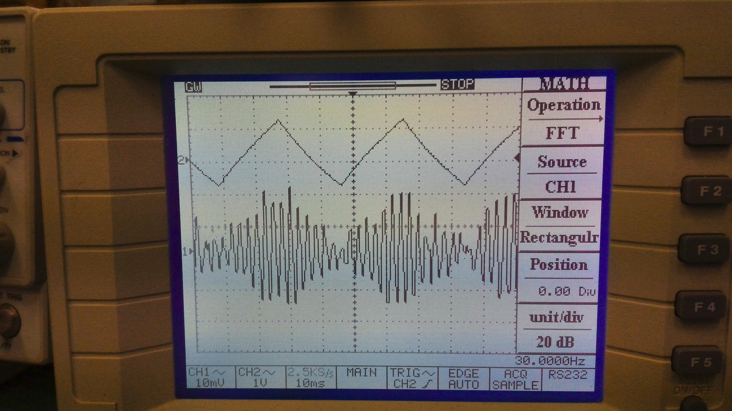

Picture 1: Amplitude modulation of triangle wave

Amplitude modulation of square wave is shown below. Similarly, lowest amplitude of the output was observed as nearly 10 mV and highest amplitude was observed as nearly 32mV.

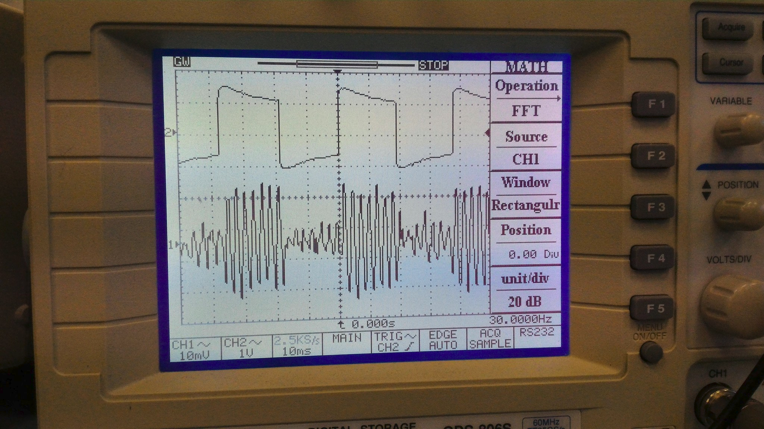

Picture 2: Amplitude modulation of square wave